**IP-CAAP(M)xxA11C**

**QSFP28 100Gb/s Active Optical Cable DDM**

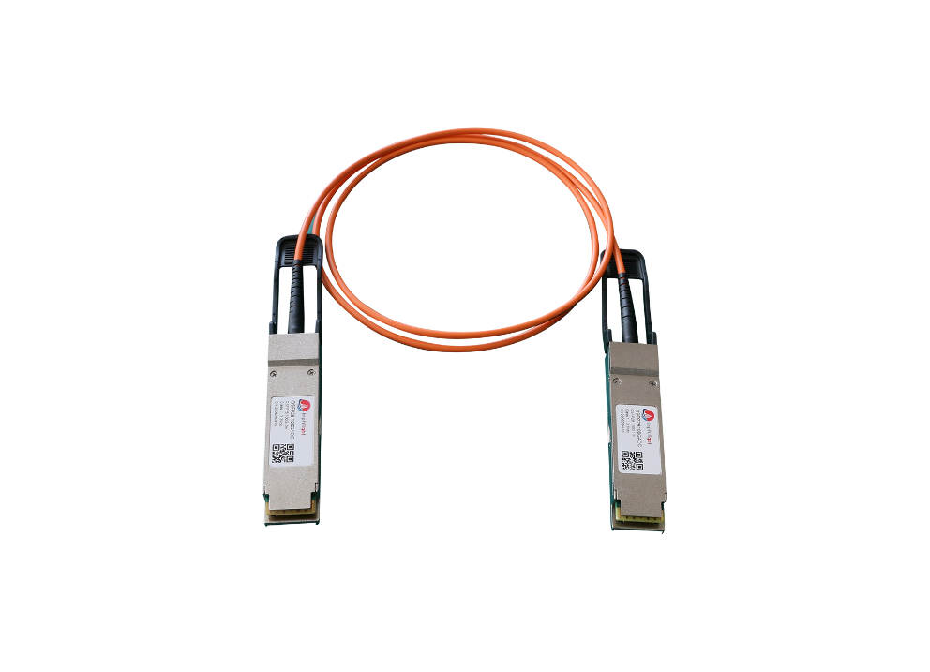**PRODUCT FEATURES**

* Multirate capability:10.3125Gb/s to 25.75125Gb/s per channel
* Reliable VCSEL array technology using multimode fiber
* Four-channel full-duplex active optical cable
* Hot pluggable
* QSFP28 high-density form factor
* Round OFNP-rated cable
* Low power dissipation:<3.5W per cable

end (< 2.5W with CDRs off)

* RoHS-6 Compliant
* Compliant with SFF-8636
* Commercial operating case temperature range:0℃ to +70℃

**APPLICATIONS**

**COMPLIANCE**

* QSFP28 MSA
* SFF 8636
* RoHS
* InfiniBand QDR
* 100G Ethernet
* Fiber Channel
* HPC interconnections

**PRODUCT DESCRIPTION**

The IP-CAAP(M)xxA11C is a QSFP28 active optical cable (AOC) for 100Gb/s optical links. It is compliant with the QSFP28 MSA, IEEE P802.3bm 100GBASE- SR4 specifications. It operates at 25.78Gb/s and the cable length is up to 100M.

**CONTACT INFORMATION**

InphilightCo., Ltd

Building 5, Zone E, Guangguxin Center, No.52, Road liufang, Jiangxia district, Wuhan, Hubei, China

If you need more details about datasheet, please contact sales

[sales@inphilight.com](mailto:sales@inphilight.com)

**REVISION HISTORY**

|  |  |  |
| --- | --- | --- |
| **Version No.** | **Date** | **Description** |
| 1.0 | June 24, 2019 | Preliminary datasheet |
| 1.1 | Jaunury 14,2021 | Add descriptive information |